Source Code pertama.c
#include <stdio.h>
int A;
int B;
int C;
void main()
{
printf("Masukkan angka pertama : ");scanf("%d",&A);
printf("Masukkan angka kedua : ");scanf("%d",&B);
C=A+B;
printf("Hasil jumlahnya adalah C=%d",C);
}
Screenshot pertama.c
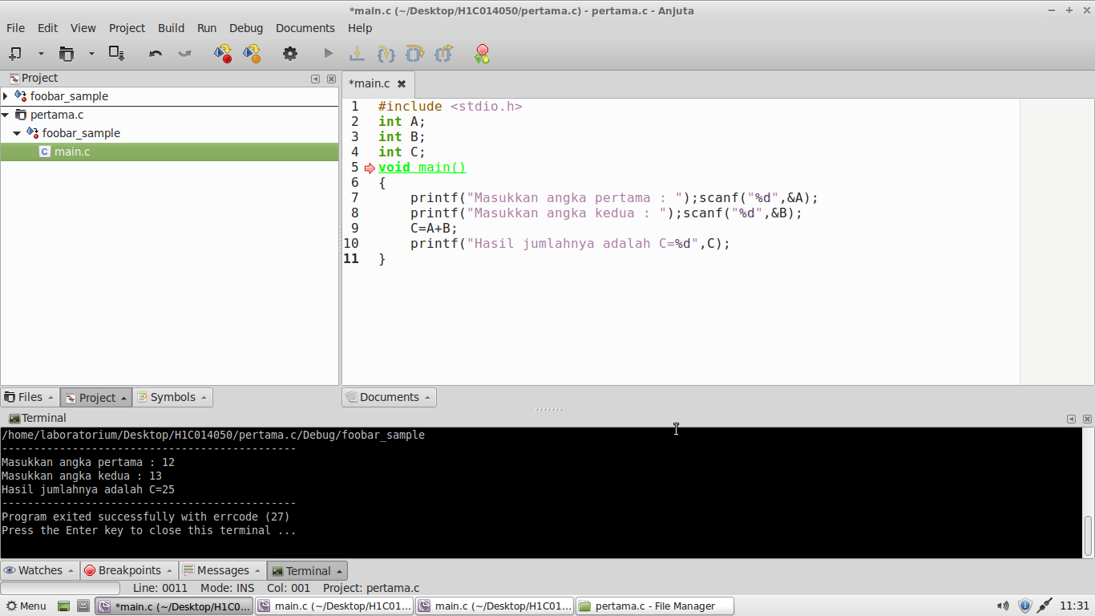
Source Code tegangan.c
#include <stdio.h>
int main()
{
int arus, hambatan, tegangan;
arus = 10;
hambatan = 500;
tegangan = arus * hambatan;
printf("Voltase = %d", tegangan);
return(0);
}
Screenshot tegangan.c
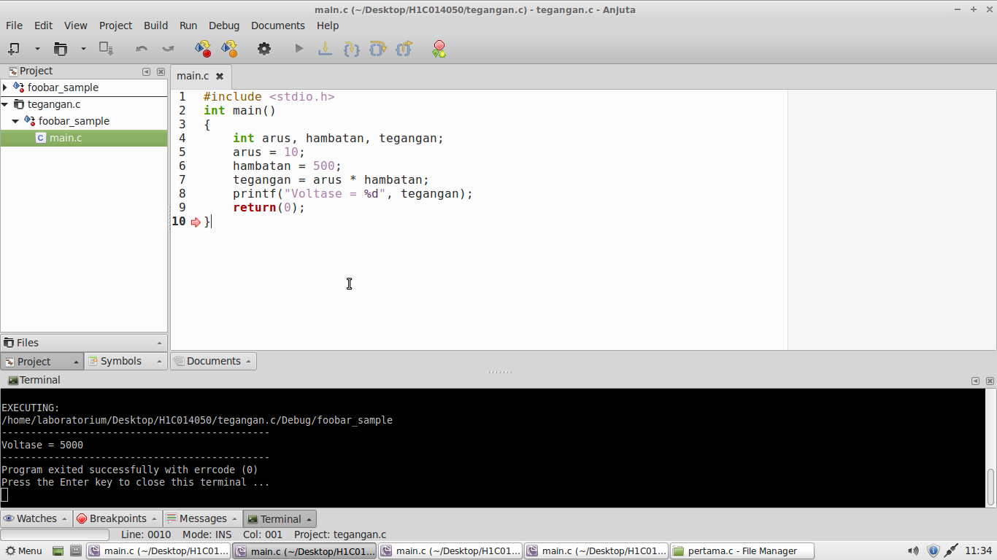
Source Code kapasitansi.c
#include <stdio.h>
int main()
{
int Q, V, C;
printf("Masukkan banyaknya muatan (Q): ");scanf("%d",&Q);
printf("Masukkan besarnya tegangan (V): ");scanf("%d",&V);
C=Q/V;
printf("Besarnya kapasitansi adalah %d",C);
}
Screenshot kapasitansi.c
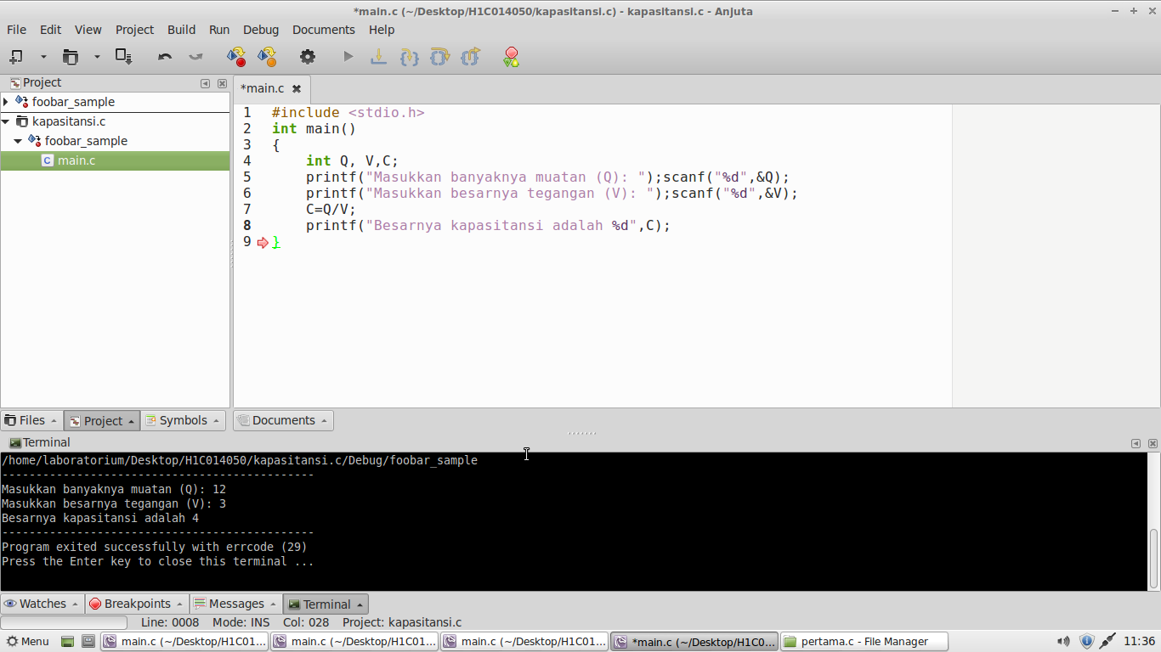
Source Code jawab.c
#include <stdio.h>
main ()
{
int jawab, hasil;
jawab = 100;
hasil = jawab - 10;
printf("Jawabannya adalah %d\n", hasil + 6);
}
Screenshot jawab.c
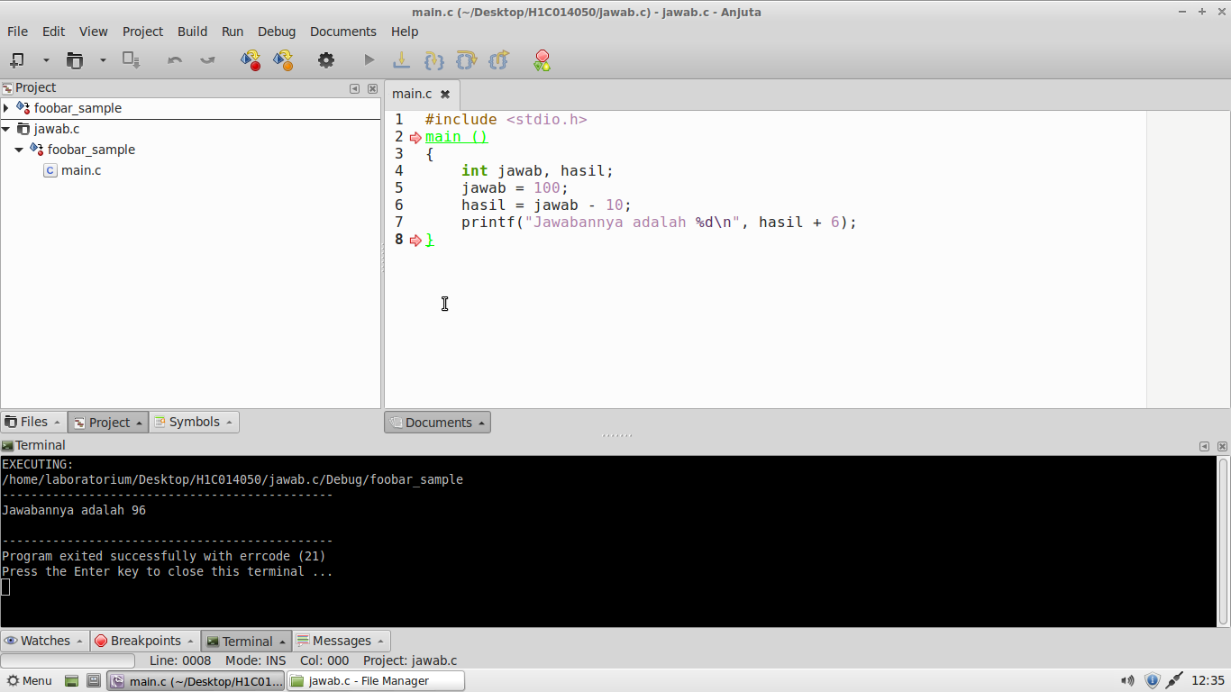
Source Code keluas.c
#include <stdio.h>
int main()
{
float pi=3.14;
float jari_jari, luas, keliling;

jari_jari = 7.0;
luas = 0.5 * pi * jari_jari * jari_jari;
keliling = 2 * pi * jari_jari;

printf("luas lingkaran %f\n",luas);
printf("keliling lingkaran %f\n",keliling);
}
Screenshot keluas.c
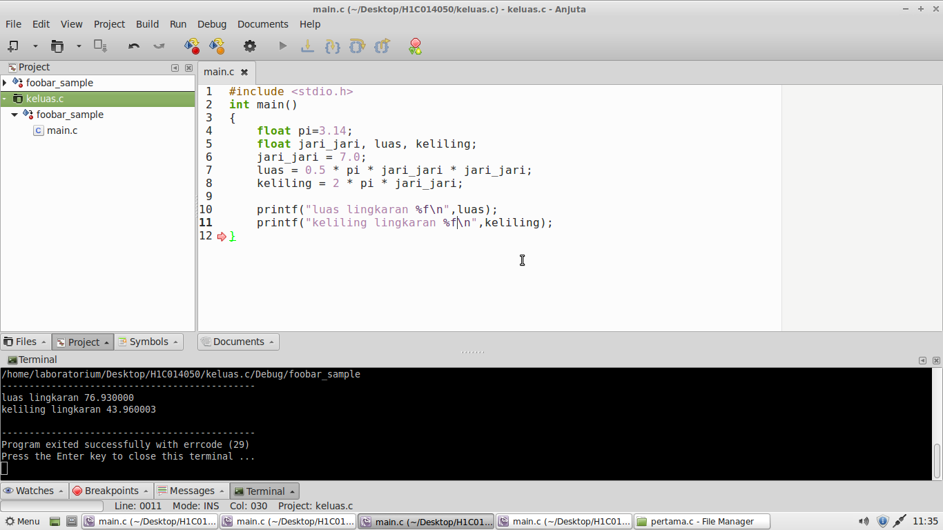
Source Code keluas2.c
#include <stdio.h>
main ()
{
int a;
float c;
char *S;
a=250;
c=2.5;
S="Hallo Unsada";
printf("\nNilai a : %d",a);
printf("\nNilai a : %5d",a);
printf("\nNilai c : %f",c);
printf("\nNilai c : %3f",c);
printf("\nNilai c : %3.1f",c);
printf("\nNilai c : %3.2f",c);
printf("\nNilai c : %3.4f",c);
printf("\nData S : %s",S);
printf("\nData S : %15s",S);
printf("\nData S : %-15s",S);
printf("\nData S : %25s",S);
printf("\nData S : %-25s",S);
}
Screenshot keluas2.c
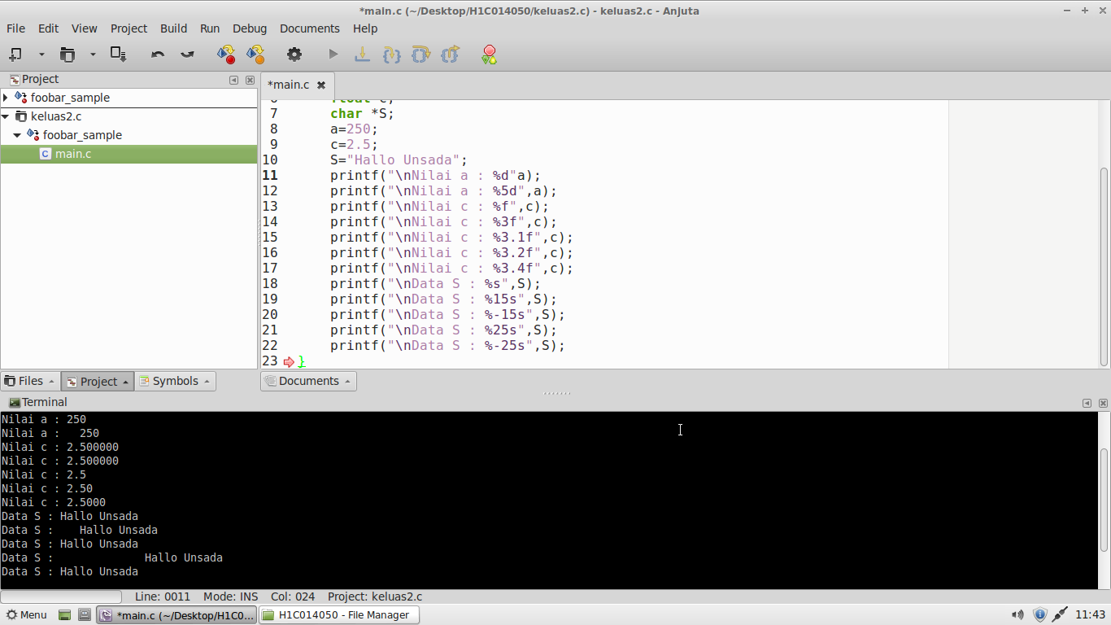
Source Code sisi_miring.c
#include <stdio.h>
#include <math.h>
int main()
{
int a, b, c;
printf("Masukkan sisi tegak : ");scanf("%d",&a);
printf("Masukkan sisi alas : ");scanf("%d",&b);
c = sqrt(a*a + b*b);
printf("Panjang sisi miring : %d",c);
}
Screenshot sisi_miring.c
